Deploying aks cluster using biceps,az client and terraform:
- Github: https://github.com/Abhiramikannan/docker-spring-boot.git
- Import this on aex.dev.azure.com
- Added: aks-cluster.bicep(code for creating aks cluster using biceps)
Using azure cli:
- Opened:
azure portal:
- Created a vm:
- az group create --name abhi-rg-12 --location eastus
- az vm create --resource-group abhi-rg-12 --name abhi-vm --image "Ubuntu2204" --size Standard_B1s --vnet-name abhi-vnet-2 --subnet abhi-subnet-2 --admin-username abhi --admin-password Abhirami@12345
- connected to the vm:
  - ssh abhi@20.169.216.239

Opened:
Aex.azure.dev.com
Create a service connection ->docker hub
- project settings -> agent pool -> add pool
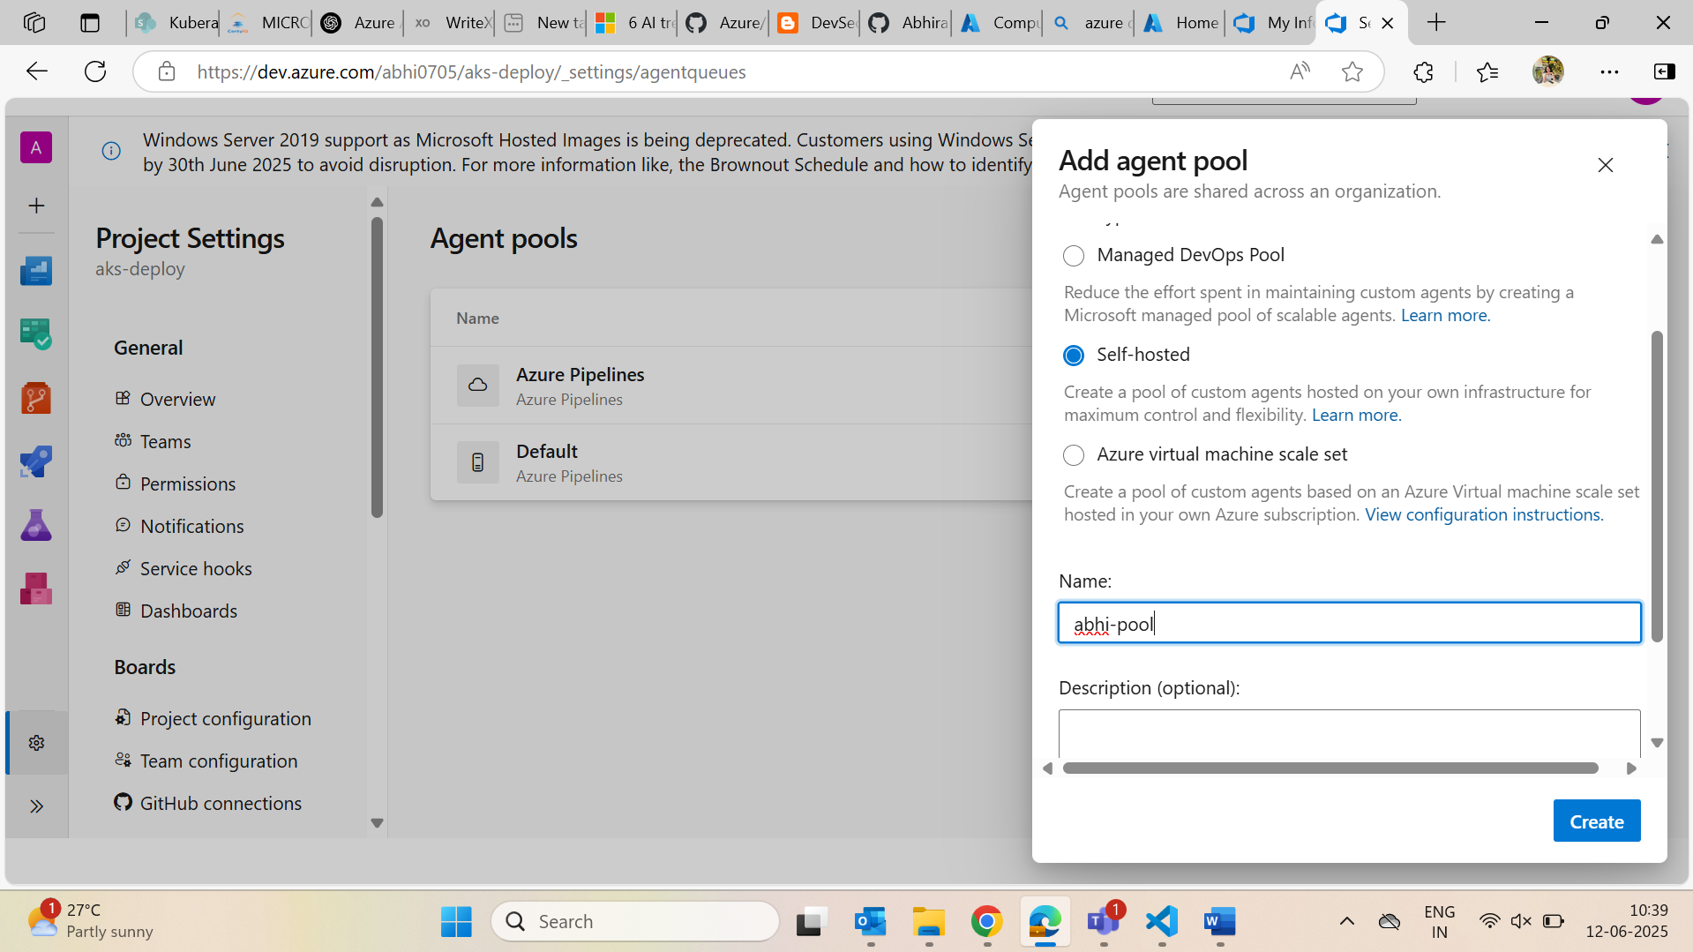
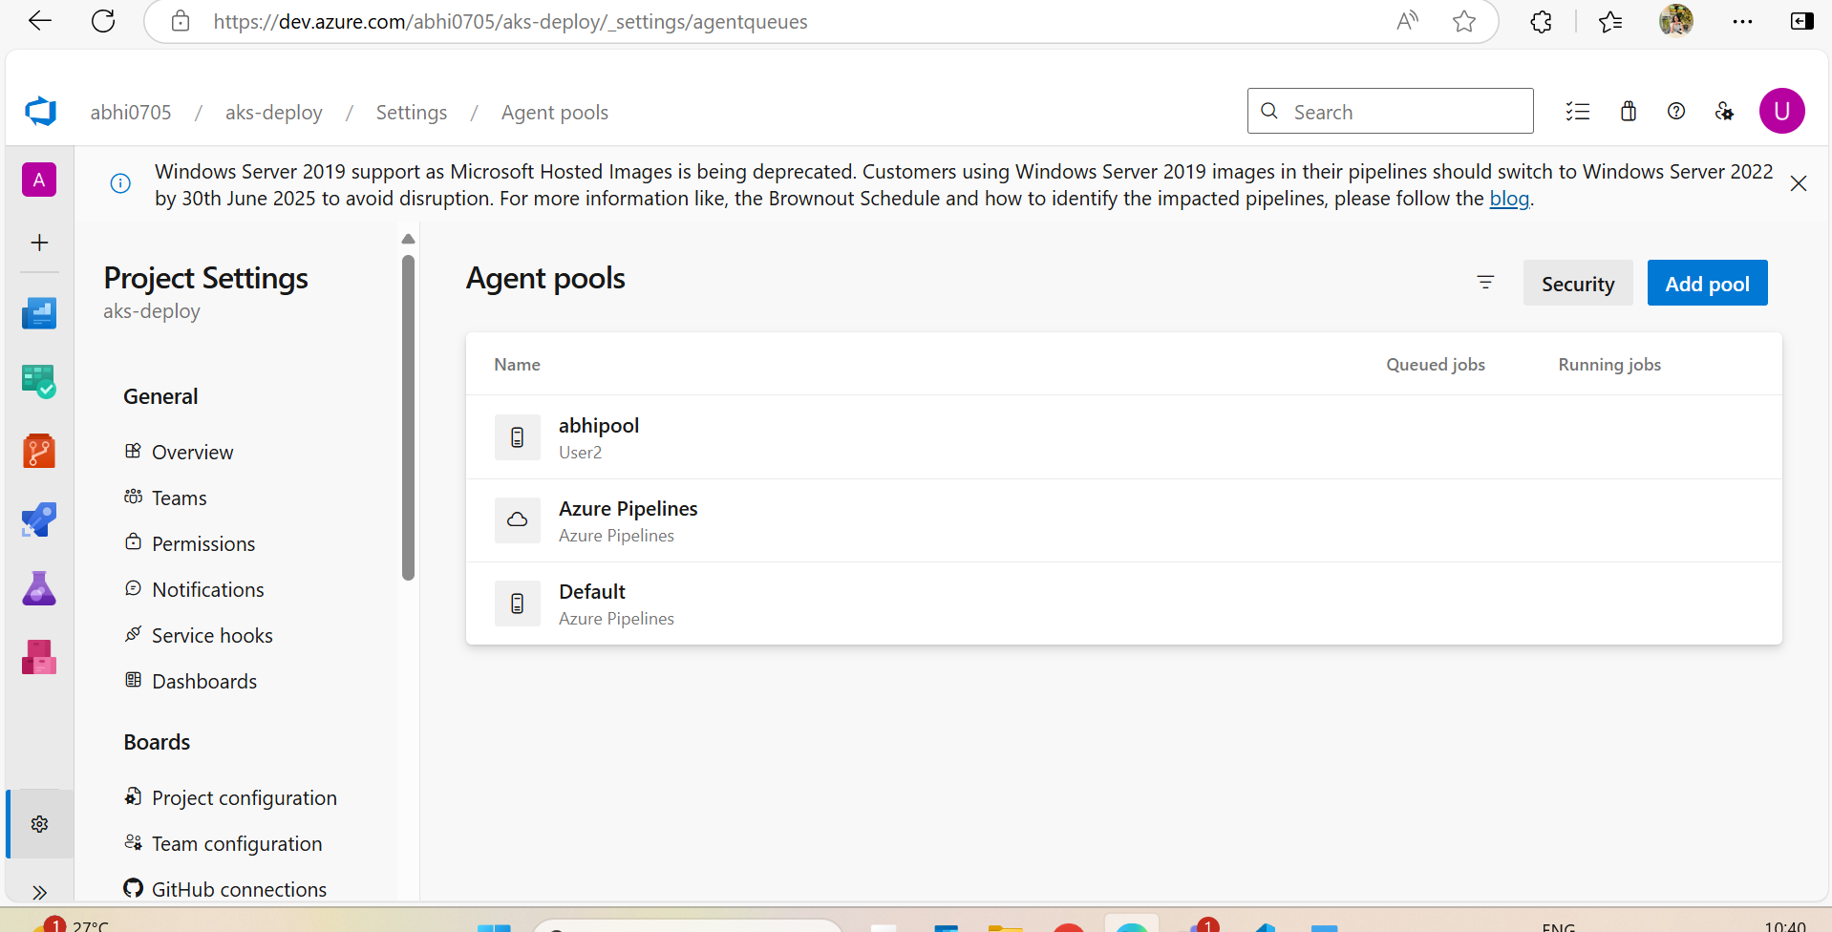
- adding an agent
- linux
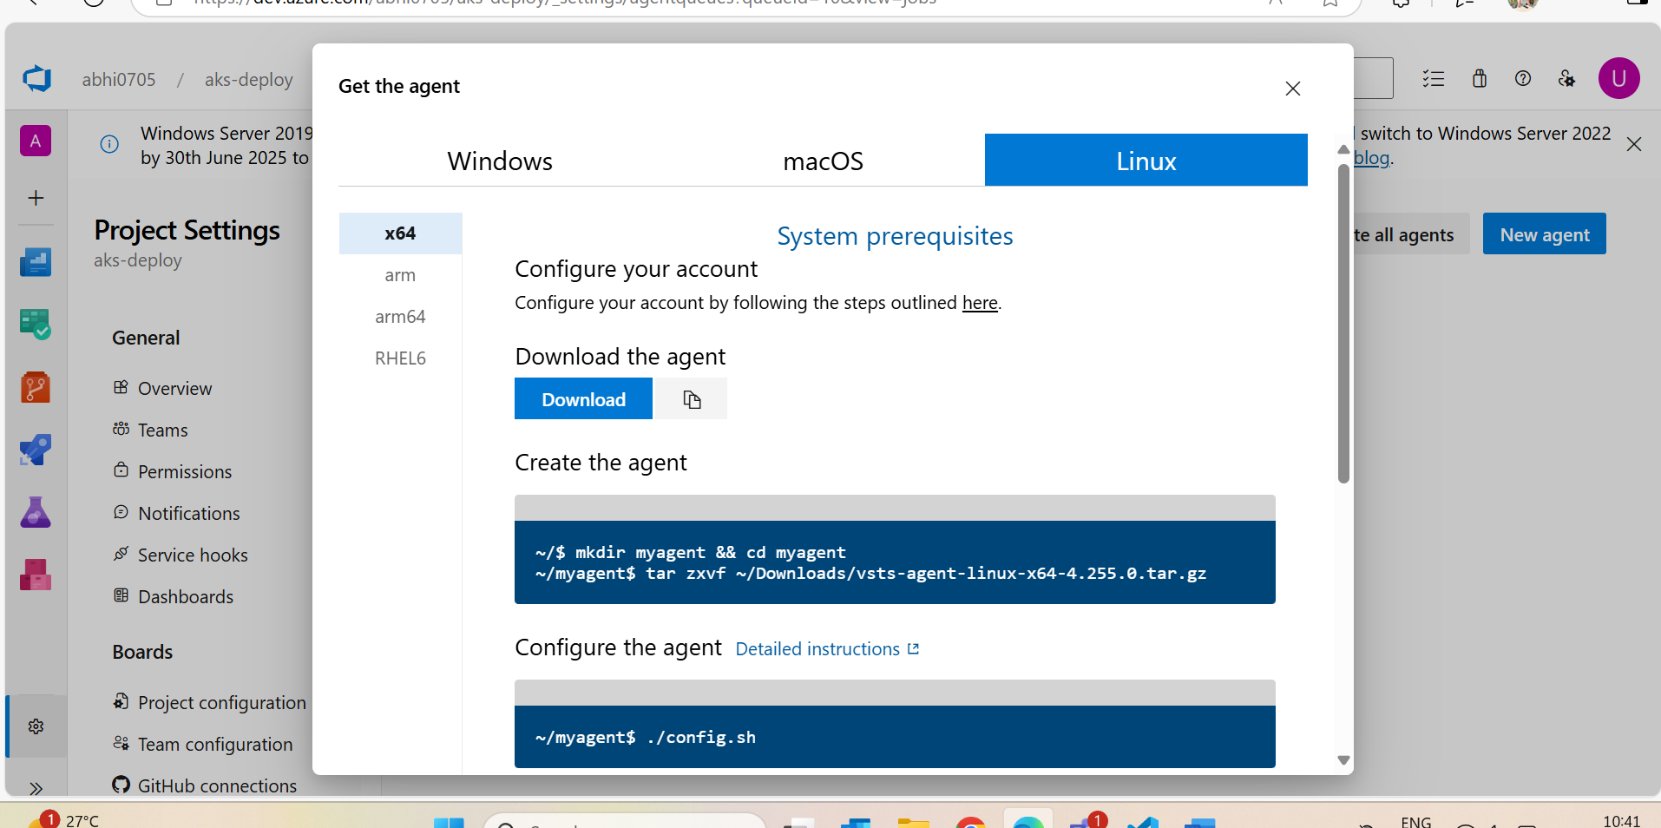

- steps inside vm:

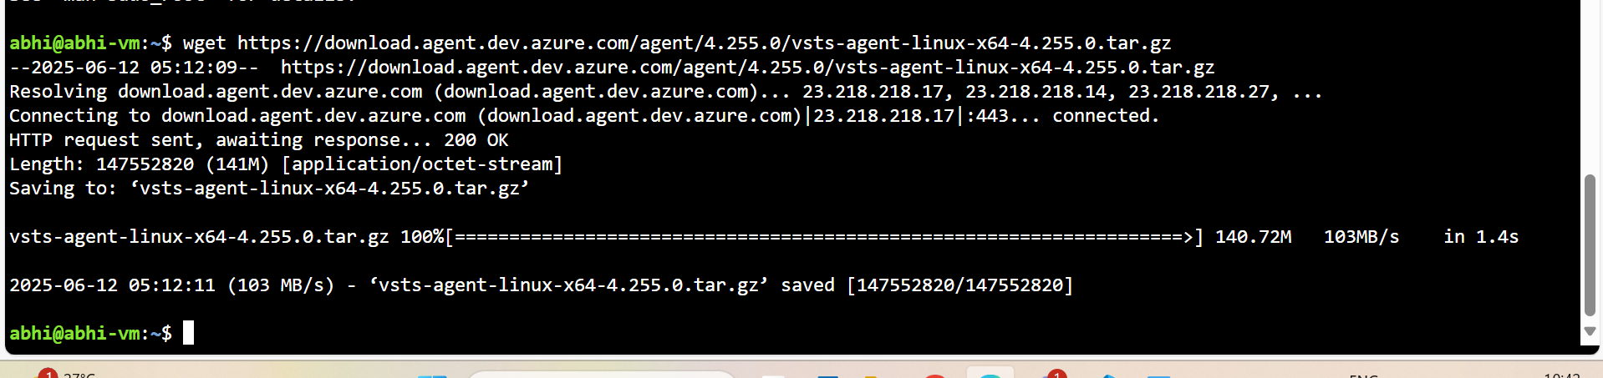
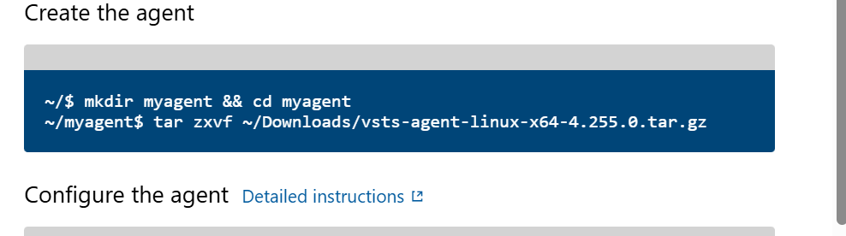
I have changed the location as tar zxvf ../vsts-agent-linux…………

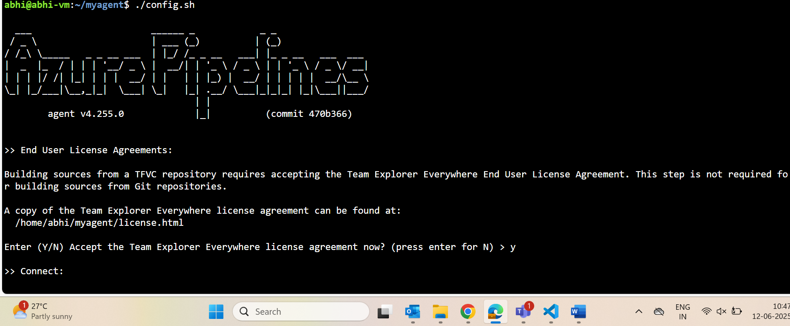

- generated pat from aex.dev.azure.com and gave here
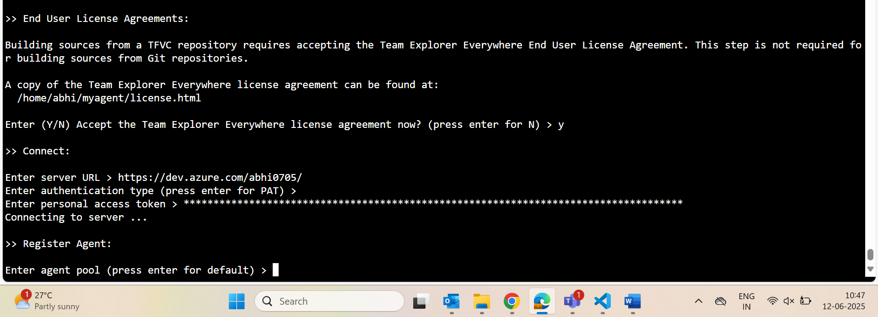
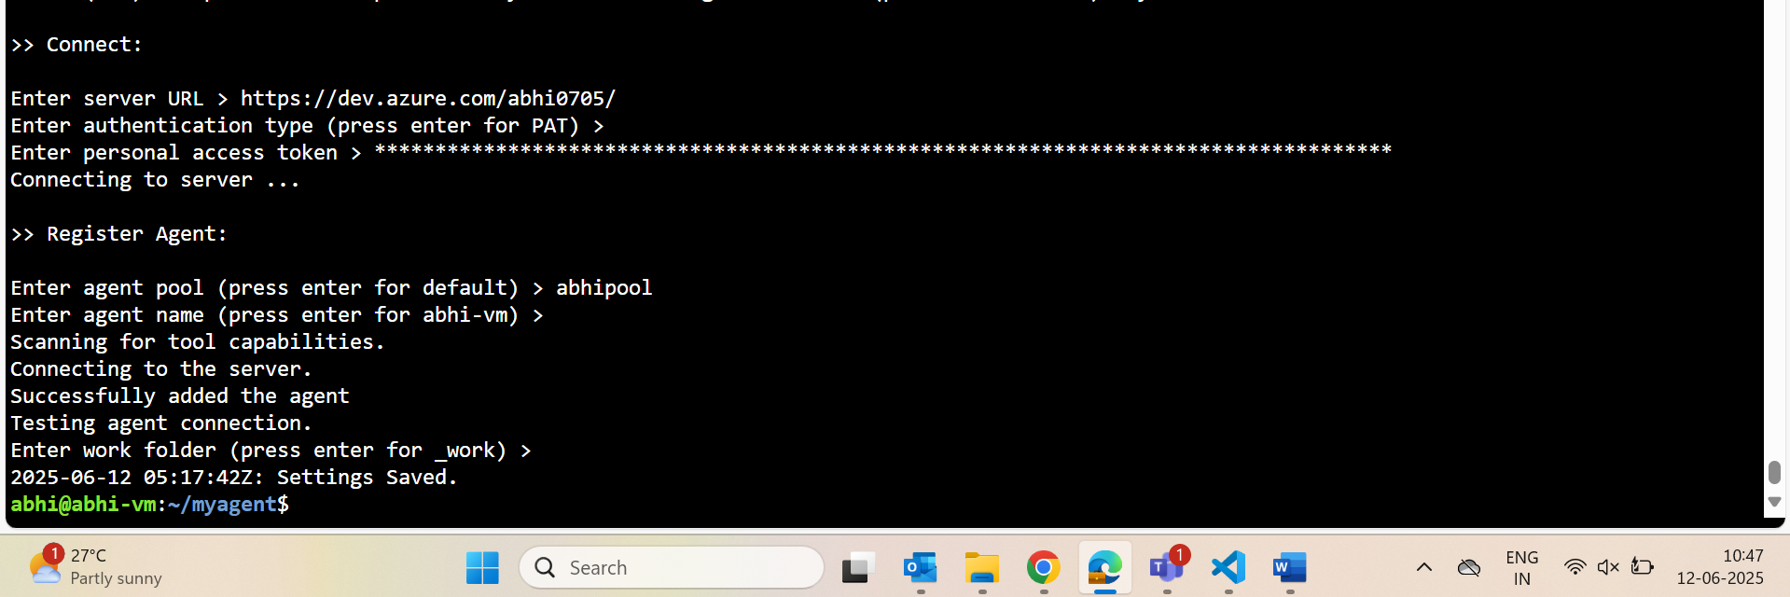

Commads for creating got from: DevSecOps and Cloud Computing Coaching: Search results for azure pipeline to deploy to aks
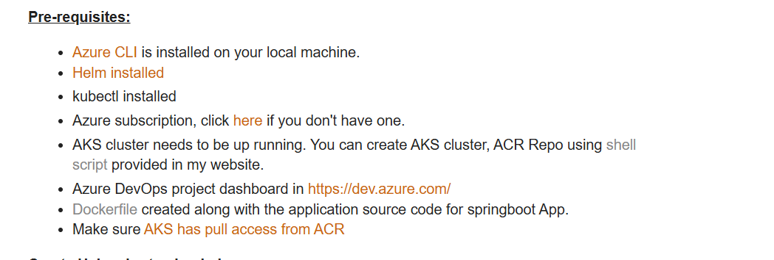
Click shell

- create aks using az client
  - az aks create --resource-group abhi-rg-12 --name abhiakscluster --node-count 1 --generate-ssh-keys --node-vm-size standard_B2s
create container registry using az client
  - az acr create --resource-group abhi-rg-12 --name abhiregistry --sku Standard --location eastus

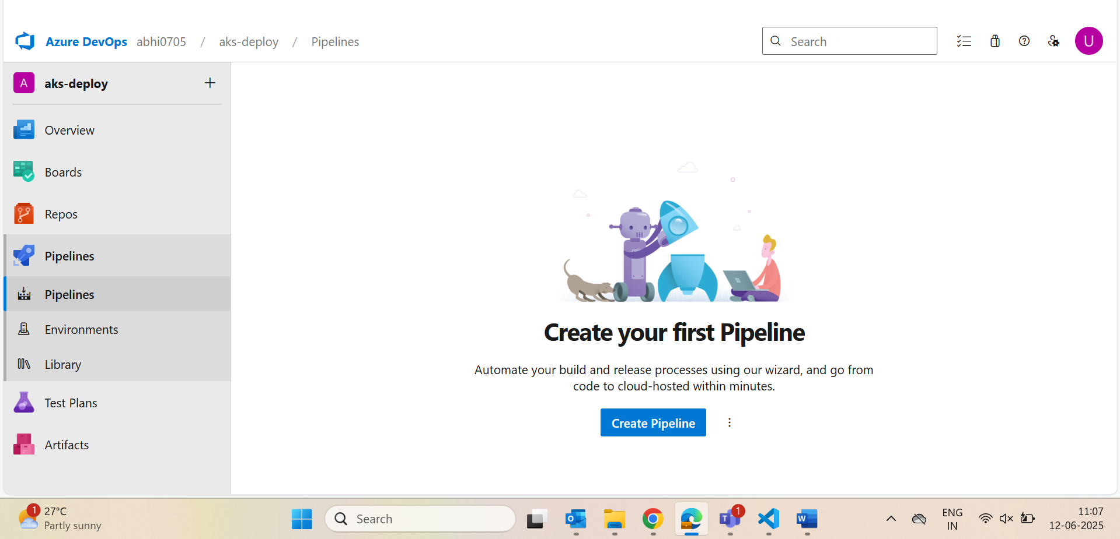
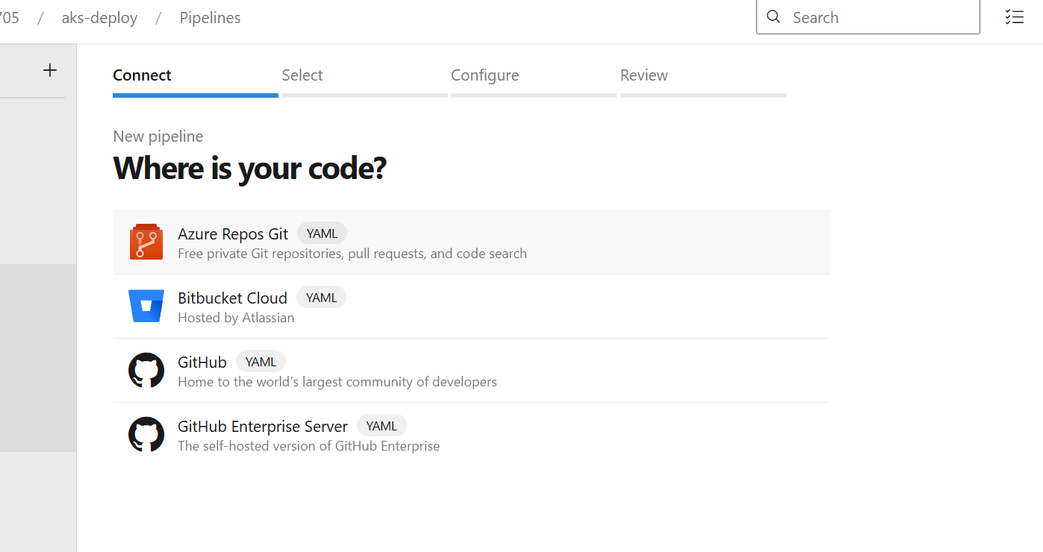
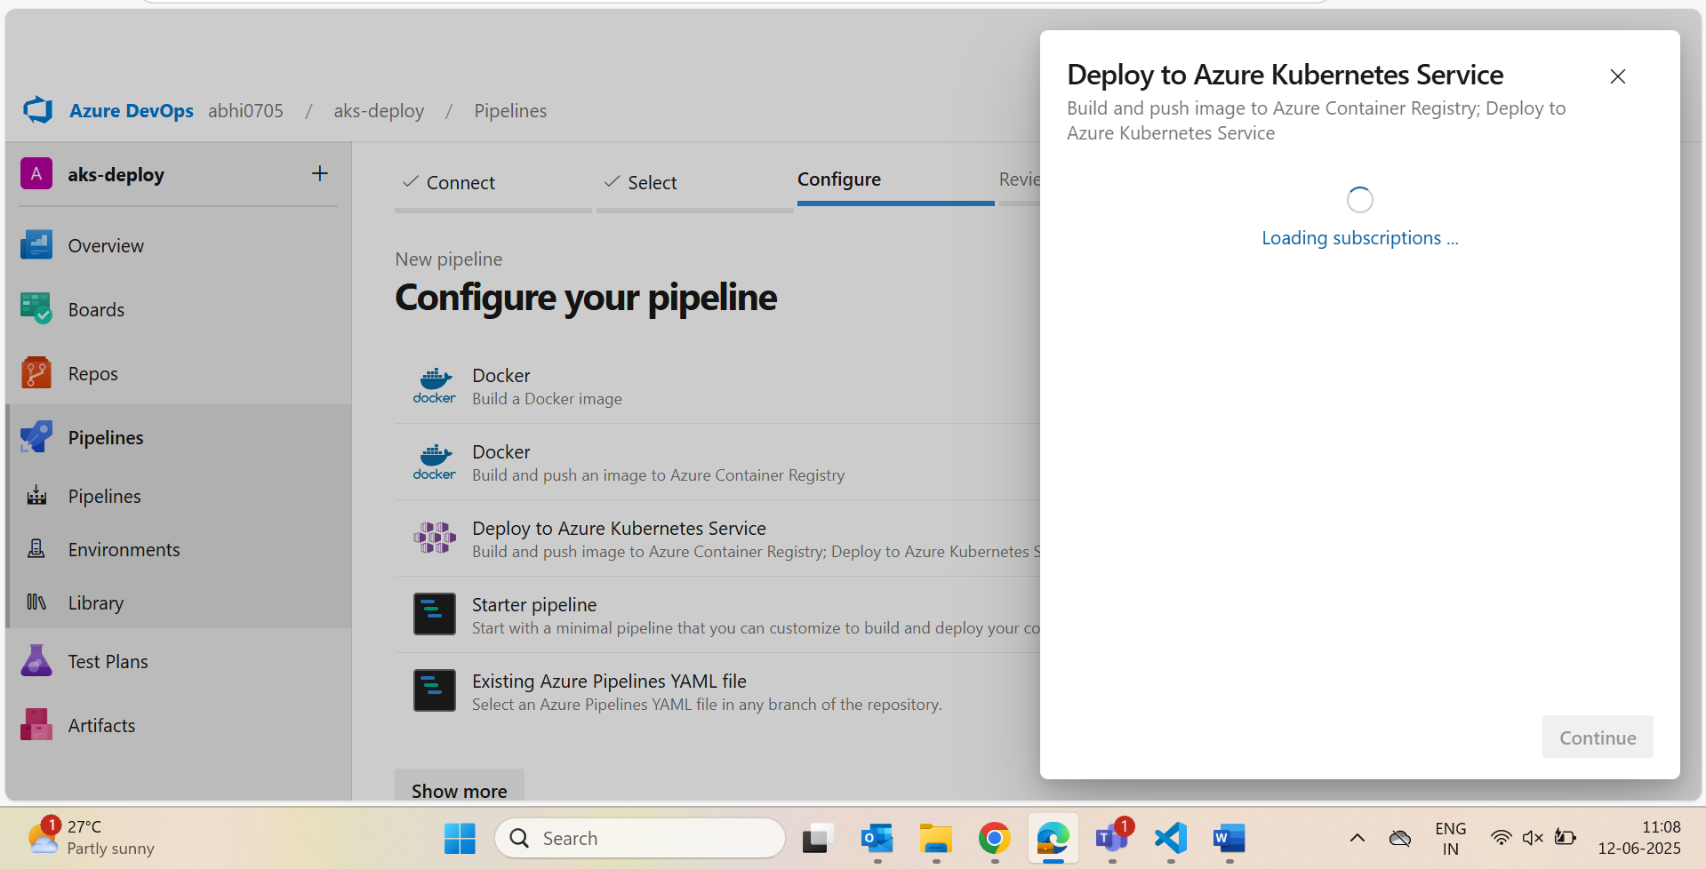

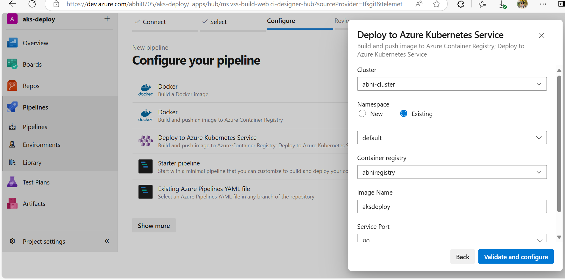
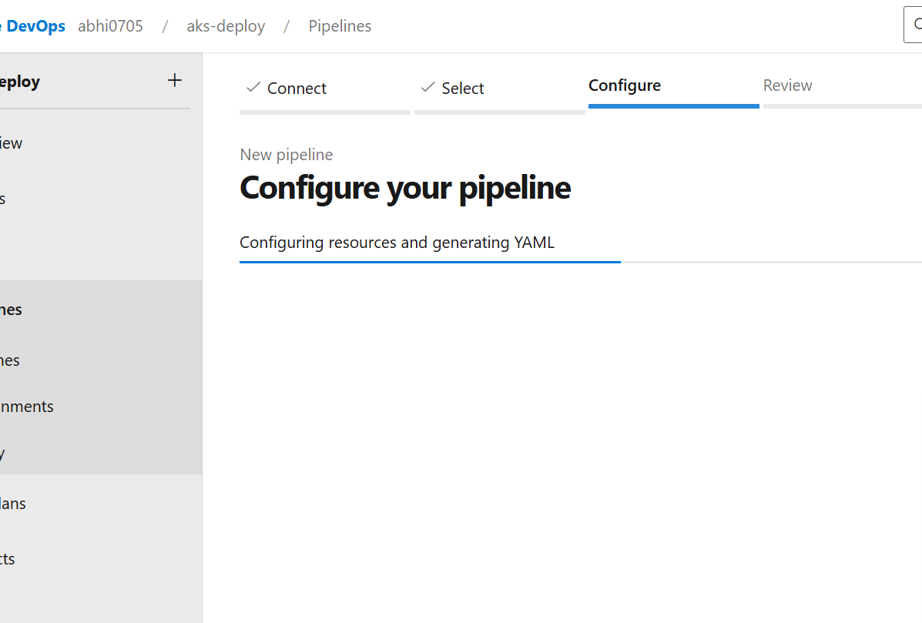
  - Gave pipeline automatically and we need to insall maven and docker
  - 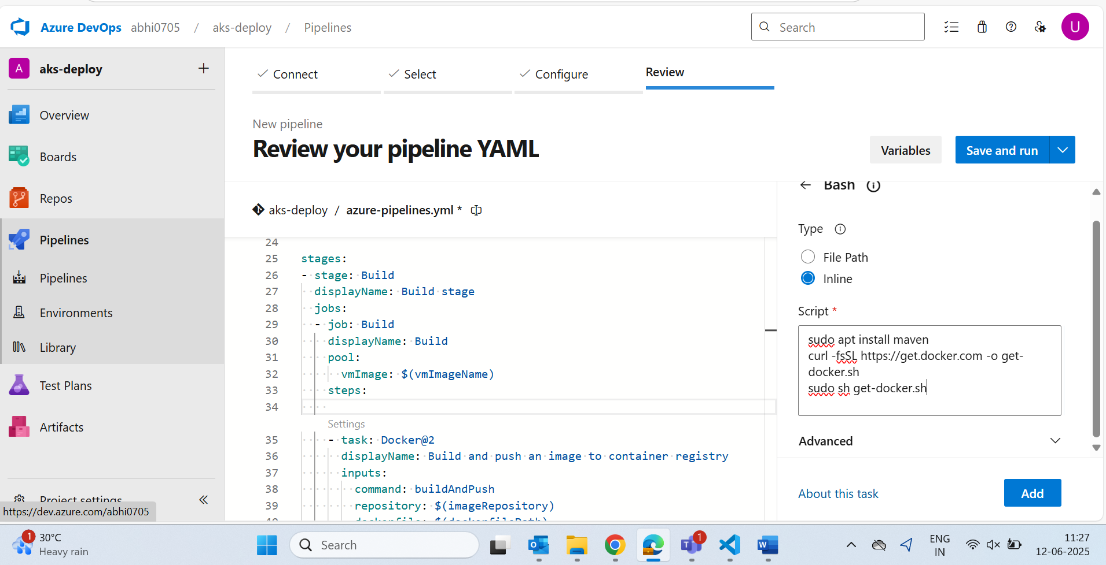

  - For mvn clean install a package manager is there ..search maven and will give that

  - Either u can give here as shell and execute commands

  - Otherwise in the workspace like jenkins

  - 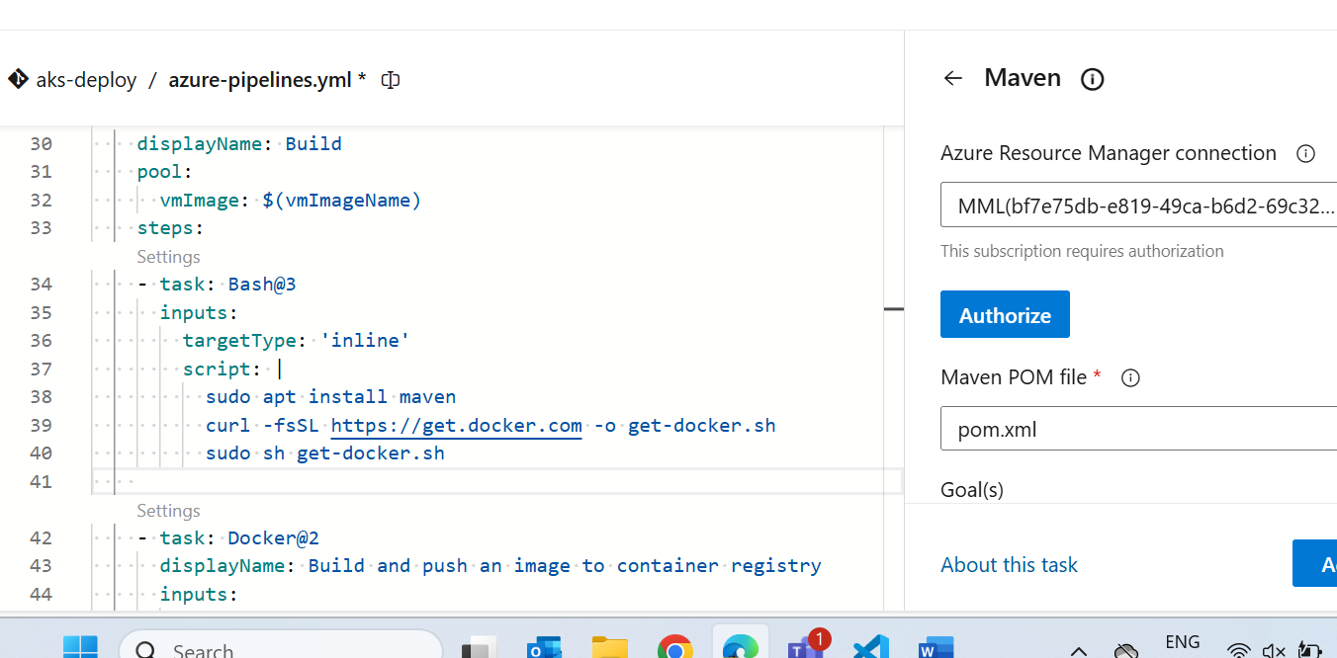

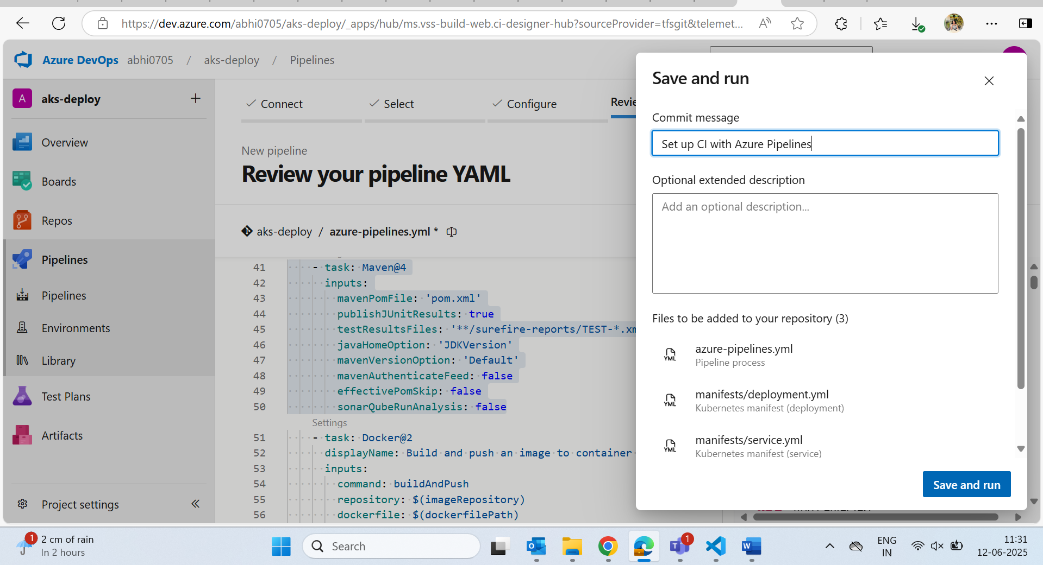

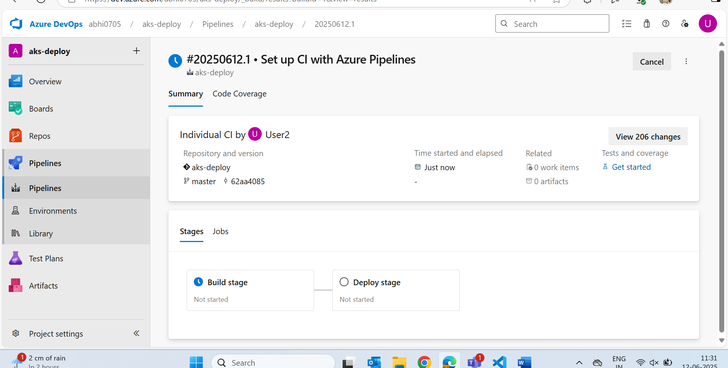

Edit:
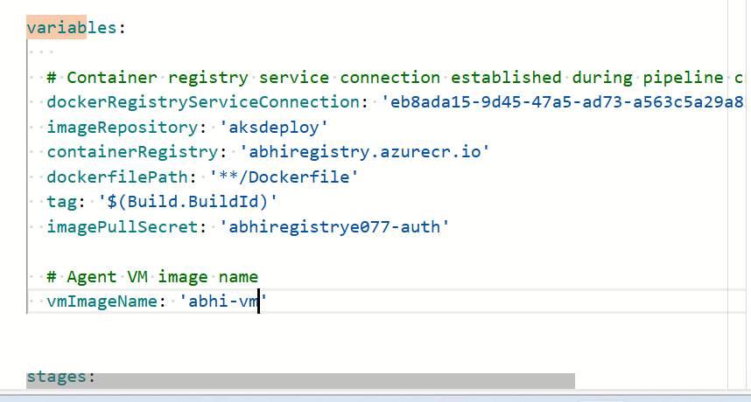

Give pool name that u have given in pool wherever it comes otherwise it takes default and gives error
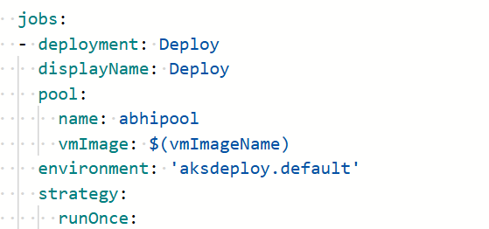

- Before build
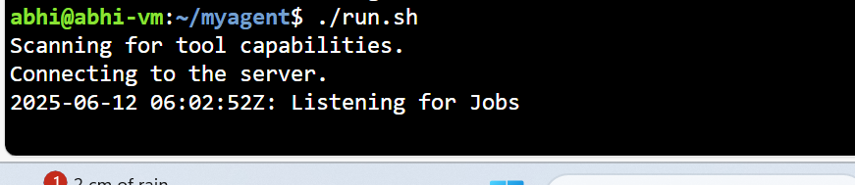
Then only agent listens

- Run
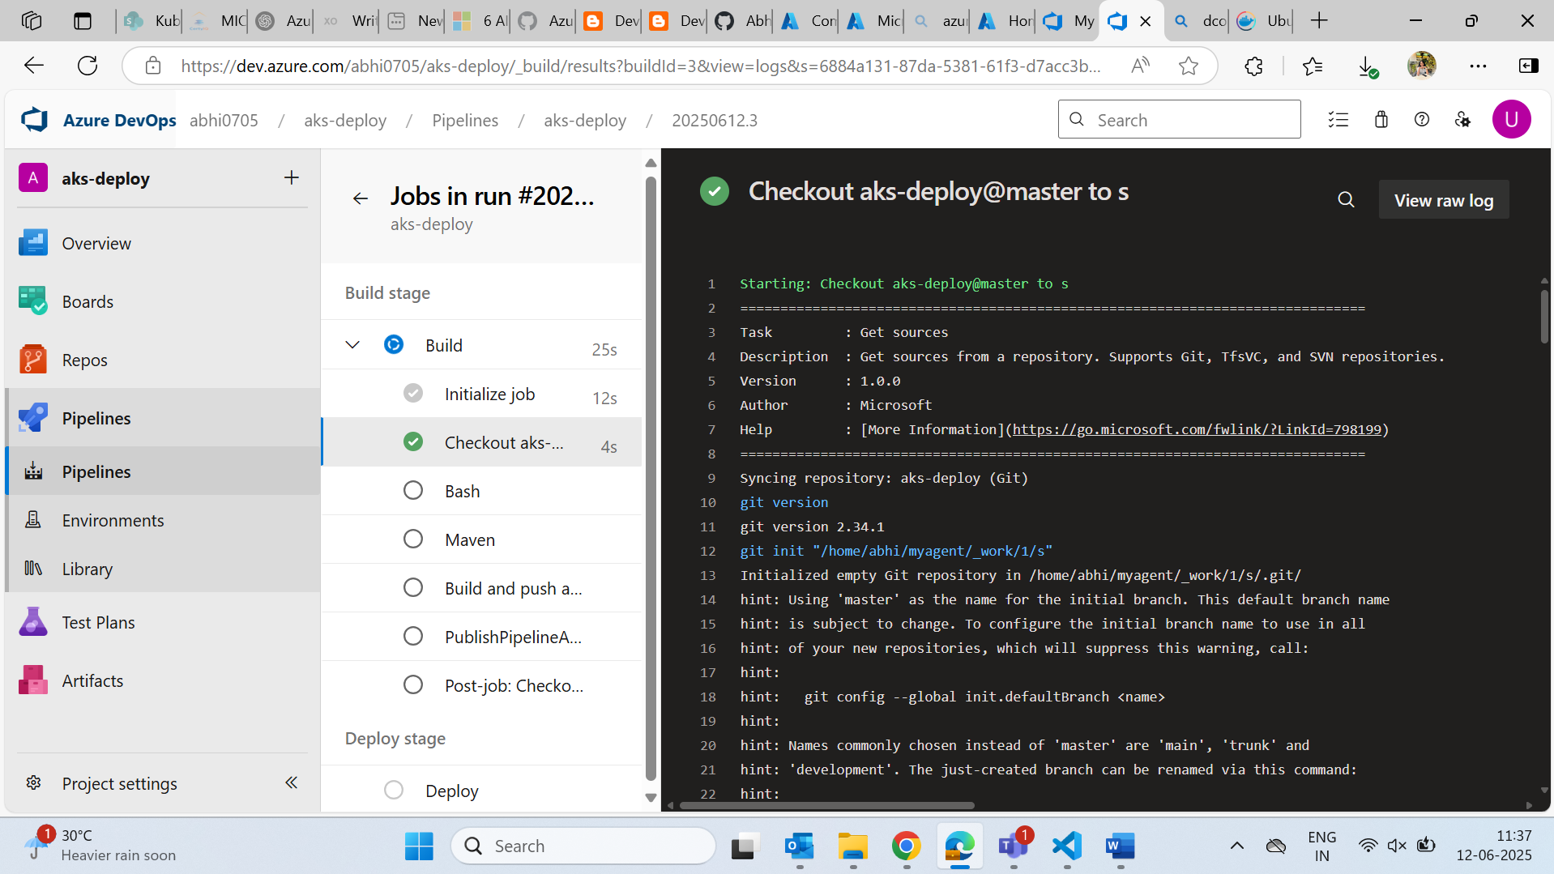
- Give vm size as standard_B2s(can resize)
- We will get an error:
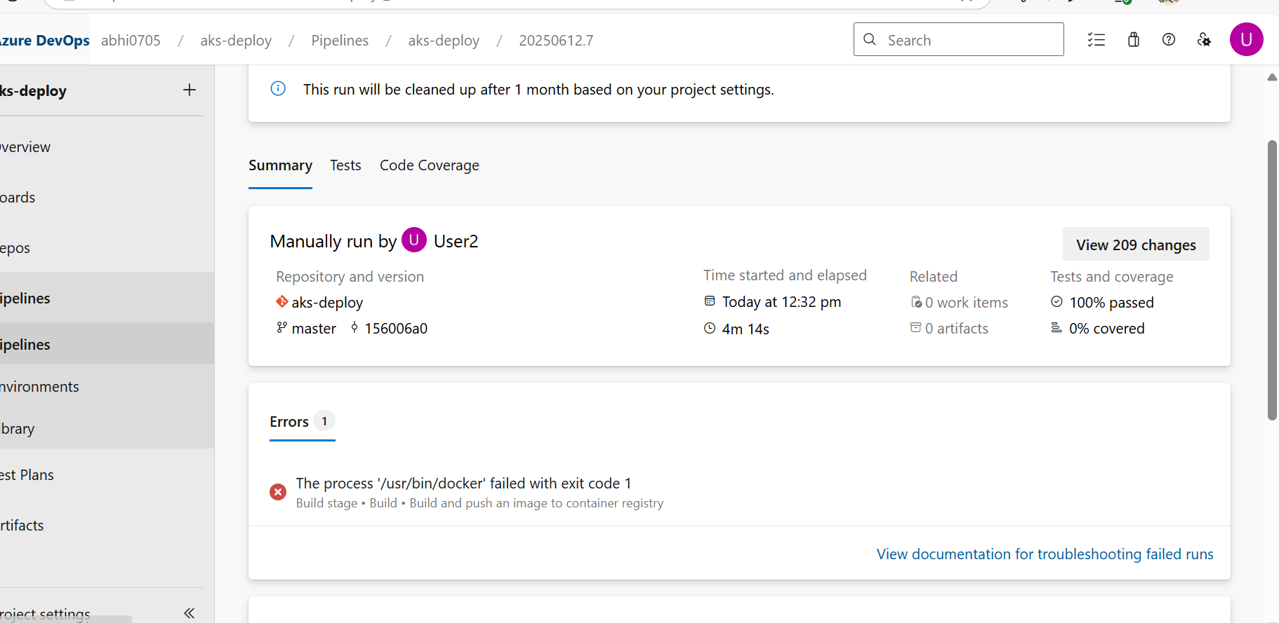

- Inside vm:

- This abhi user does not have any permission for docker
- So sudo usermod -aG docker abhi
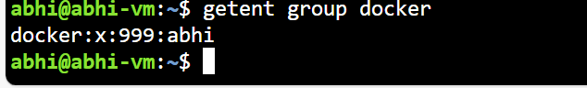

- Exit and renter to vm and check
  - docker ps
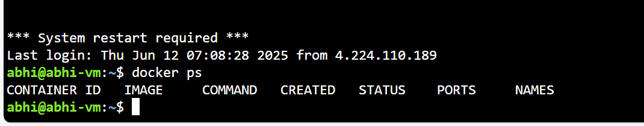
- try run the job again:
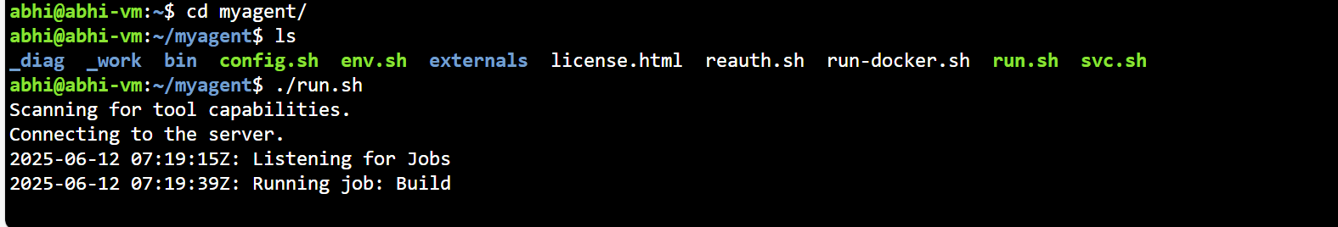

- run
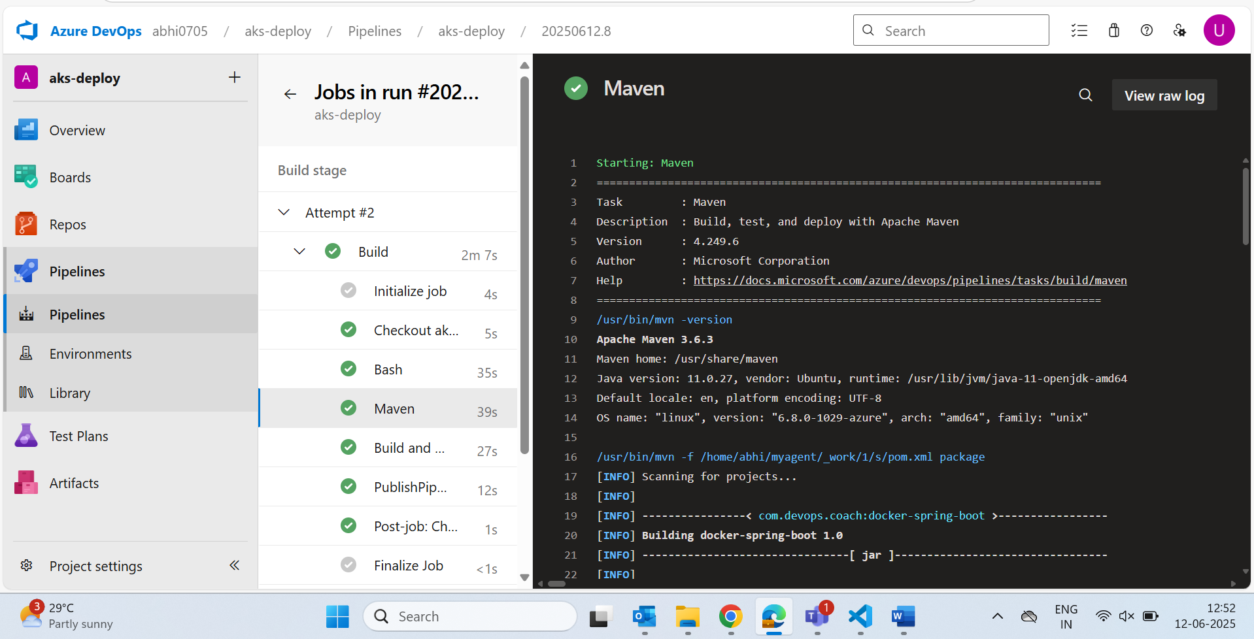

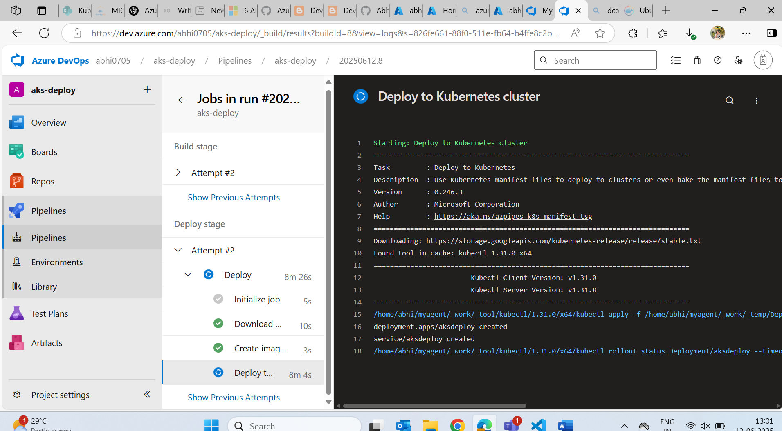

Done…

